**CIT 230 :09 1/25/2018**

**Lesson 3 Design Principles Document**

**Dane Woodruff**

**Bro. Odom instructor**

**Typography**

John Klemmer - Saxophonist

([www.johnklemmer.com](http://www.johnklemmer.com))

(screenshot) 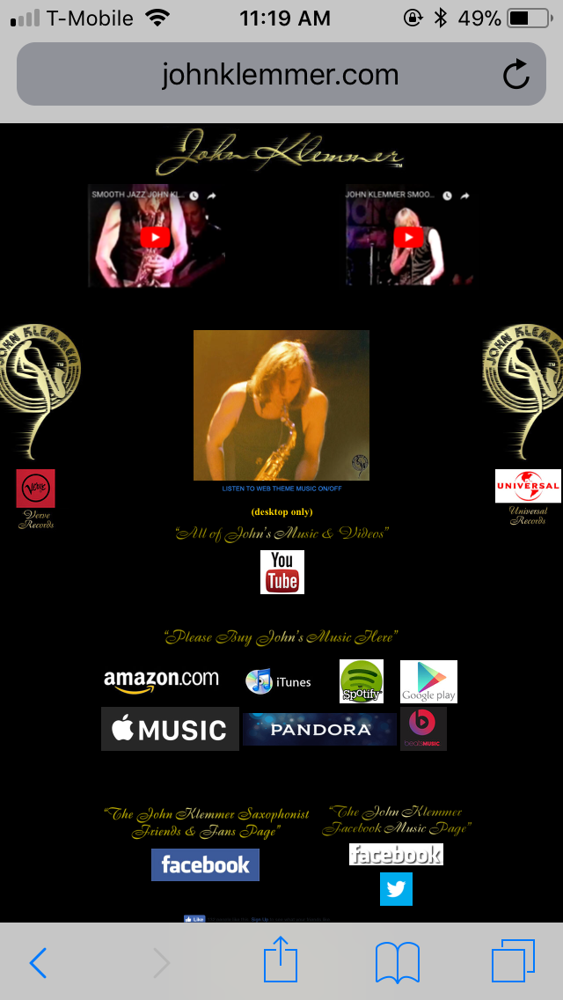

I chose this site for typography because this site, to me, was set up to appeal to someone’s mood. John Klemmer is a really smooth saxophonist in which his website perfectly reflects the tone of his music. Although it takes you a little expanding on the mobile phone to view the lettering more clearly, it’s a small sacrifice to get the “feel” of his website. The typography also compensates by not added too much text so that you feel more relaxed. The text and icons are centered so that it draws your attention to the middle where you get a close up of him playing. Nice.

**Proximity**

Duolingo – Language software

([www.duolingo.com](http://www.duolingo.com))

(screenshot) 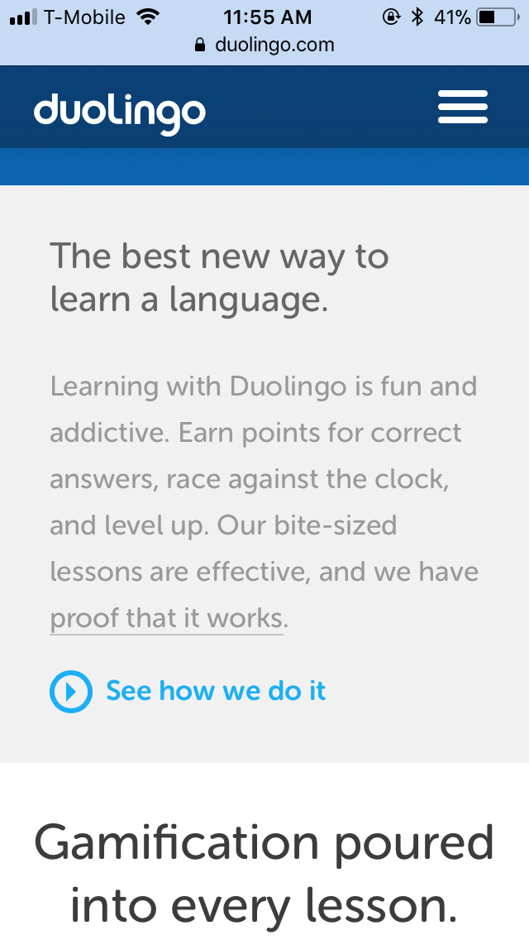

When you are concentrating heavily on the words on your device (as in this case to learn a new language), it’s the little things that count. Good spacing in a site or program seems minute, but it sure helps when the text is clear and easy on the eyes. Duolingo, even on a mobile phone feels open and easy so that my mind can concentrate on learning a language, not deciphering the text. I believe this site was designed for the phone, so that you can learn on the go.

**Repetition**

Visa

([www.usa.visa.com](http://www.usa.visa.com))

(screenshot) 

I never would advocate anyone to use a credit card, but Visa does have a pretty organized mobile website. They use a rectangular border repetition compartmentalizing their articles, ads, footer, and so forth. It all fits nicely in the boxes as you scroll down the boxcar-like menu. There is even a small floating reference tab. They packed a lot of info by organizing it well in boxes. Lots of colorful pictures keep the blockiness from becoming too boring.

**Alignment**

The Church of Jesus Christ of Latter-day Saints

([www.lds.org](http://www.lds.org))

(screenshot) 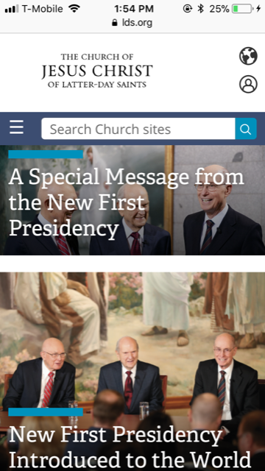

Ok, I am showing a little bias here, but that doesn’t deter from the fact that the Church doesn’t cut corners, even on their website. The text is all uniform going from left to right. The text is named, I’m sure intentionally, “Official”. So that the website suggests to your mind that you are reading official declarations from high ranking official. In our case, celestially high official. Like the Visa website, imposing (for mobile size) pictures balance out the alignment with vibrant colors and good spacing. It’s just all around good, to me.

**Contrast**

Home of the Underdogs – game emulator site

([www.homeoftheunderdogs.net](http://www.homeoftheunderdogs.net))

(screenshot) 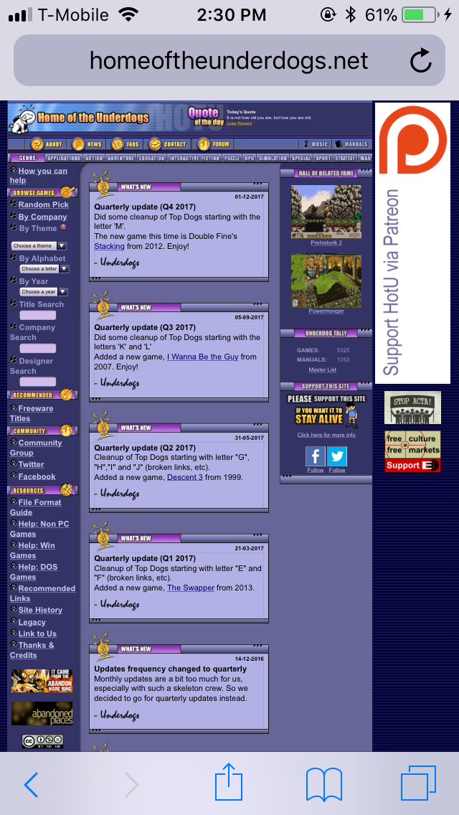

Although this site isn’t the greatest for the small text and out-of-placed ads, I chose this one for the one thing that it has going for it, contrast. Here you can see two forms of contrast that help in the look and read of this site. It has opposite colors that make the headings pop out and the light and dark of the background to make the menus pop out, even though there is a lot going on.